1. Graphical user interface, text, application, email

   Description automatically generated
2. 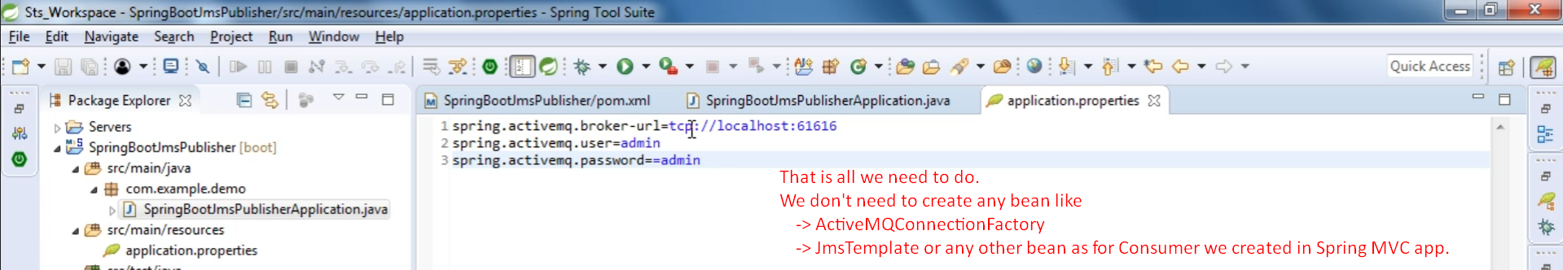
3. This configuration for consumer and producer is exactly same.